

**MET2001 System Engineering Project 1**

**Trimester 3, Academic Year 23/24**

Vehicle & Software Test Plan

**Group:** 04

**Prepared by:**

| Group Members | Registration Number |
| --- | --- |
| Bellamy Woo Zhen Yu | 2301579 |
| Chai Ze Xuan | 2301629 |
| Low Min Wei | 2301555 |
| Muhammad Ariff | 2301644 |
| Shaun Ong Zhi Peng | 2301632 |

**1. Introduction**

The purpose of this software test plan is to outline the strategy, scope, objectives, resources, and schedule for testing the components of the AMR. This test plan specifically addresses the testing of various critical components such as the PDB, Light Module, ToF Sensors, Ultrasound Sensors, E-Stop button, Vehicle command and movement and lastly the navigation algorithm verification. Each component will be tested to ensure it meets the specified requirements and functions correctly. This document provides detailed descriptions, initial states, testing steps, and pass/fail criteria for each component under test.

**2. Power Distribution Board (PDB)**

**Purpose**

* Step down the 12V from the AMR to 5V or 3.3V
* Supply power to STM/NUCLEO stack

**Initial State**

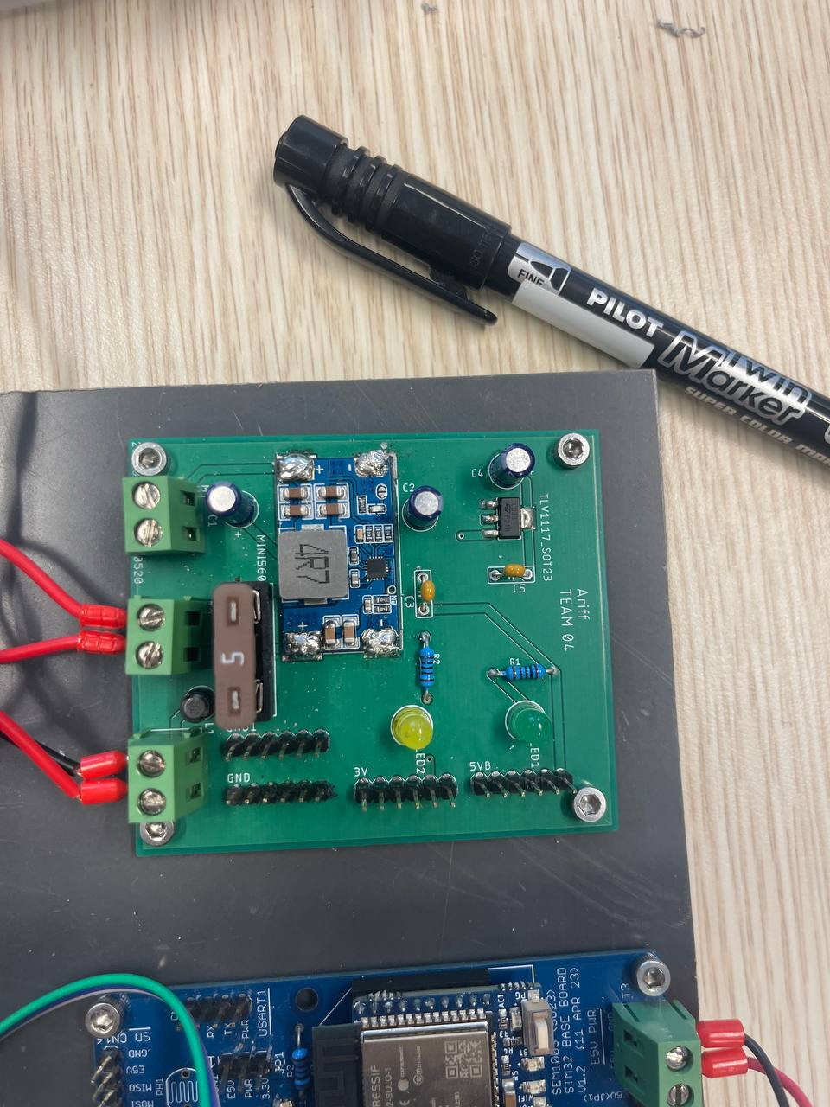

***Figure 1: PDB when no voltage is supplied to board***

**Testing Plan**

* Connect the PDB board to a 12V power supply.
* Ensure the green and yellow Led is turned on.
* Attach the Black probe of the DMM to the GND pin.
* Attach the Red probe of the DMM to the 3.3V pin.
* Turn on the DMM and ensure there is a voltage reading of 3.3V.
* Attach the Black probe of the DMM to the GND pin.
* Attach the Red probe of the DMM to the 5V pin.
* Turn on the DMM and ensure there is a voltage reading of 5V.

**Pass/Fail Criteria**

* Pass Criteria:
  + DMM Voltage value reads 3.3V and 5V for each test.
  + Green and yellow led turned on.
* Fail Criteria:
  + DMM reads various values not consisting of 3.3V and 5V.
  + DMM displays zero values.
  + Green and yellow LED not turned on.

**Testing State**

* Pictorial representation of pass condition:

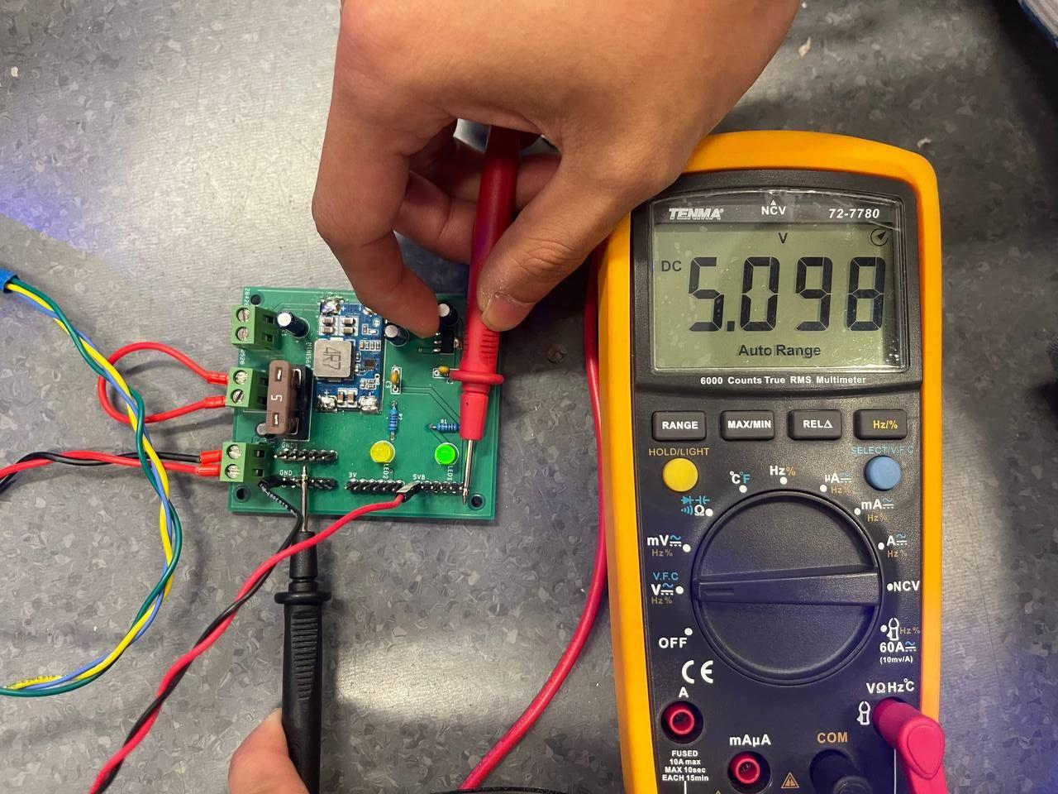

***Figure 2: PDB when voltage is supplied to the board, reading taken at the 5V pin***

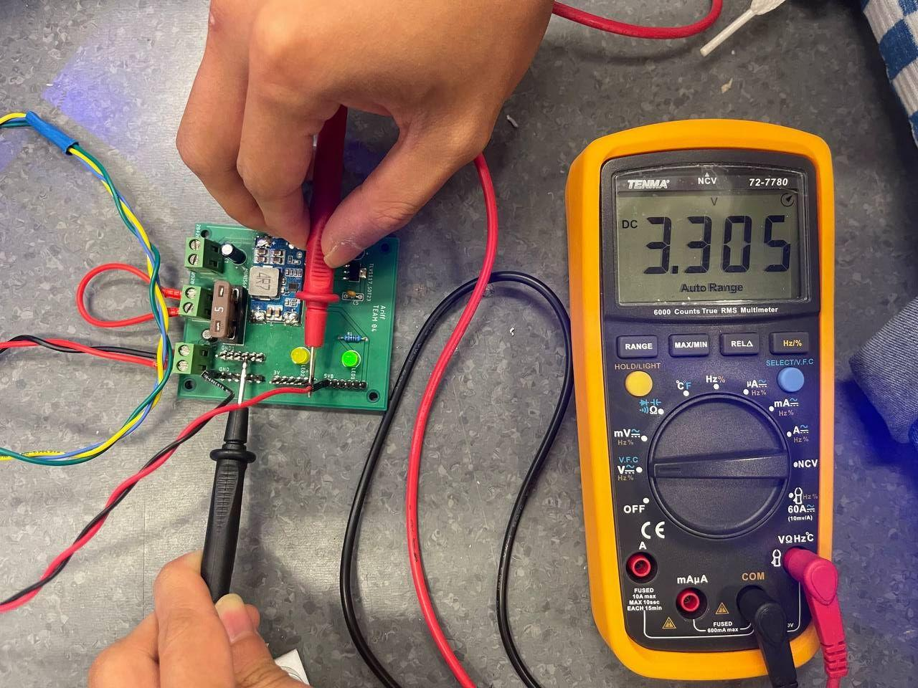

***Figure 3: PDB when voltage is supplied to the board, reading taken at the 3.3V pin***

* Pictorial representation of fail condition:

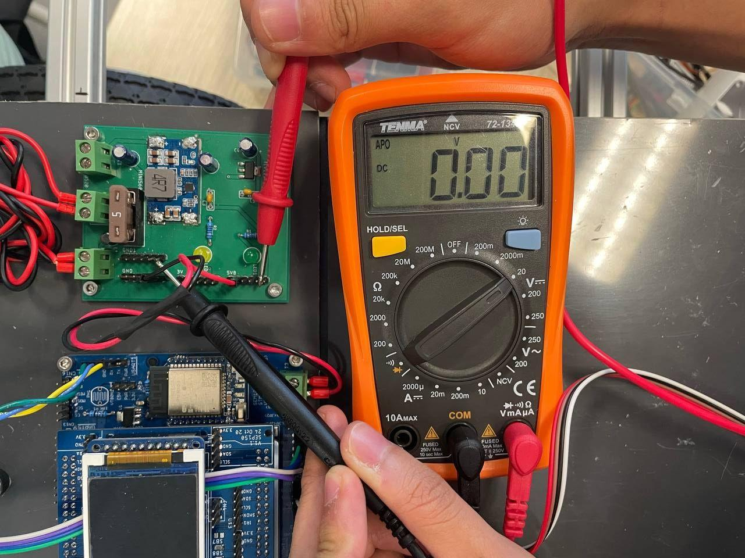

***Figure 4: Voltage is supplied to PDB but LED does not turn on and voltage pins shows 0V***

**3. Light Module**

**Purpose of light module**

* Turn on/off, change colour and blink/stay on according to coding commands.

**Initial State**

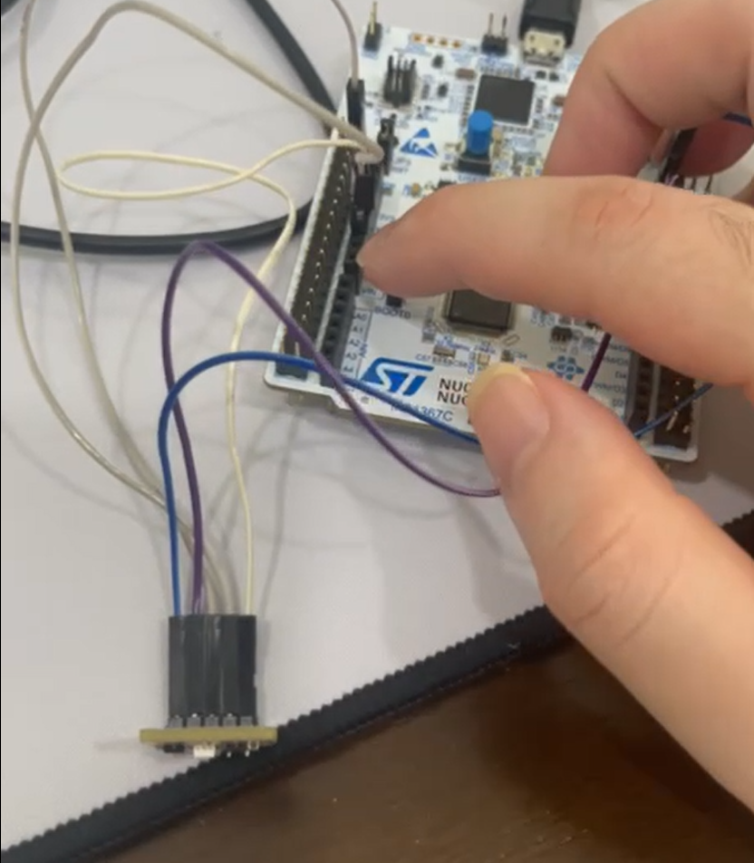

***Figure 5: Light Module is off at initial state***

**Testing Plan**

* Connect the light module’s red, green and blue pins to their respective pins on the Nucleo board.
* Connect the 3V3 and Gnd pins on the light module to their respective pins on the Nucleo board.
* Load the code into the Nucleo Board.
* Test the LED light module on, off and colour-switching functions by pressing the blue button.
* Test the reset button on the Nucleo board, pressing the reset button turns off the light module.

**Pass/Fail Criteria**

* Pass criteria:
  + Led turns on upon activating the blue button.
  + Led changes colour according to the code upon pressing the blue button.
  + Led turns white upon holding onto the blue button.
  + Led turns off upon activating the reset button.
* Fail criteria:
  + Led does not turn on upon pressing the blue button.
  + Led does not perform a colour switching function.
  + Led does not turn off upon pressing the reset button.

**Testing State**

* Pictorial representation of pass condition:

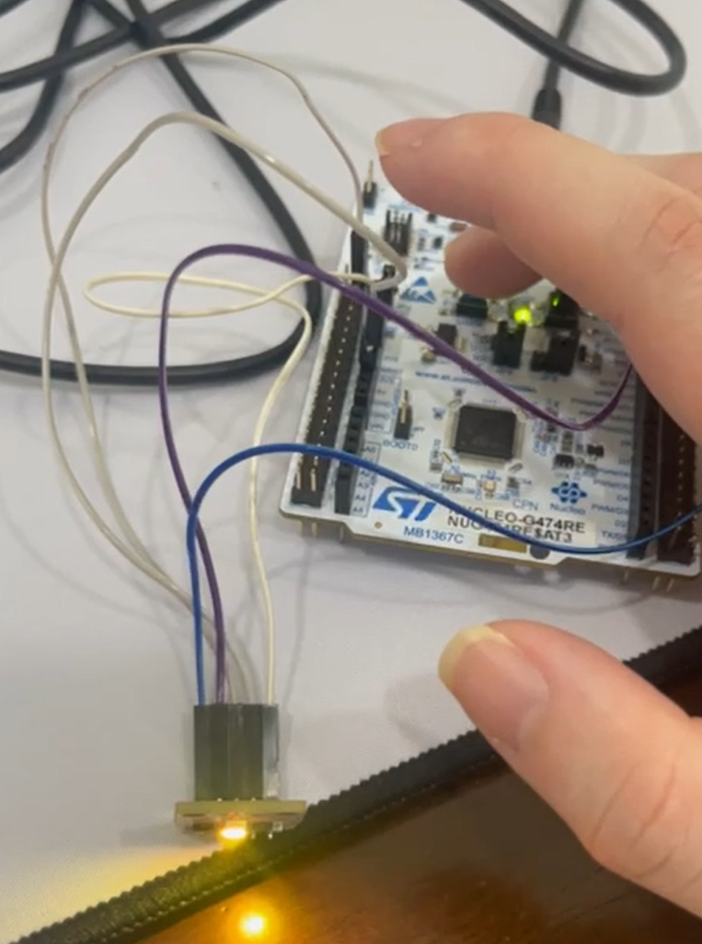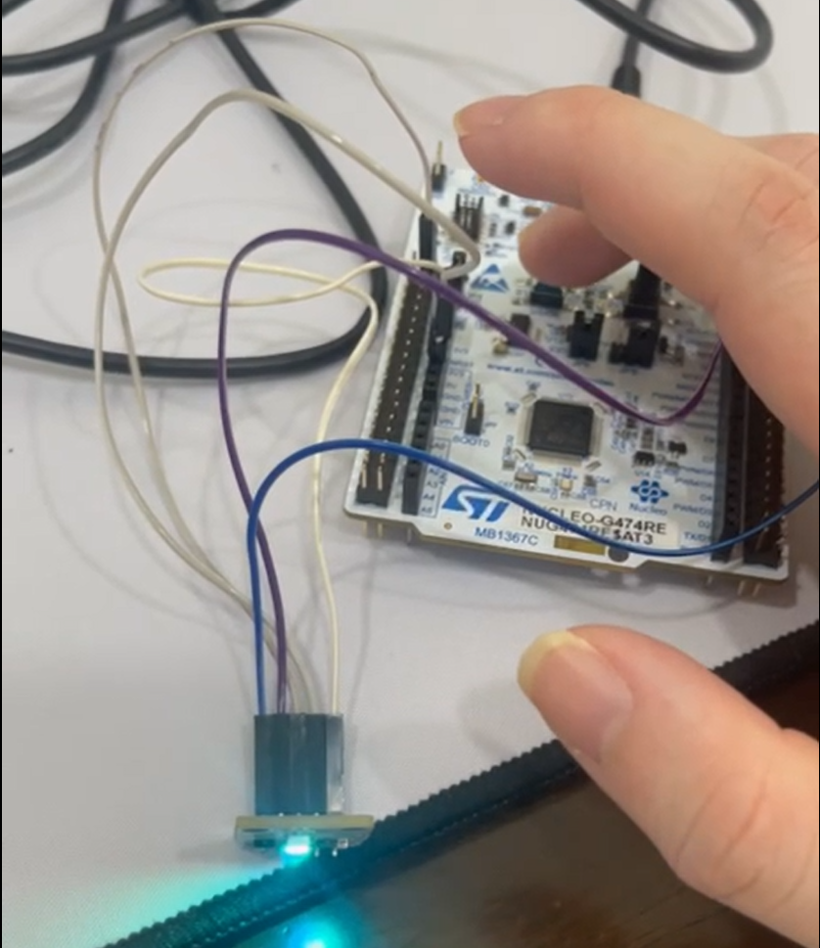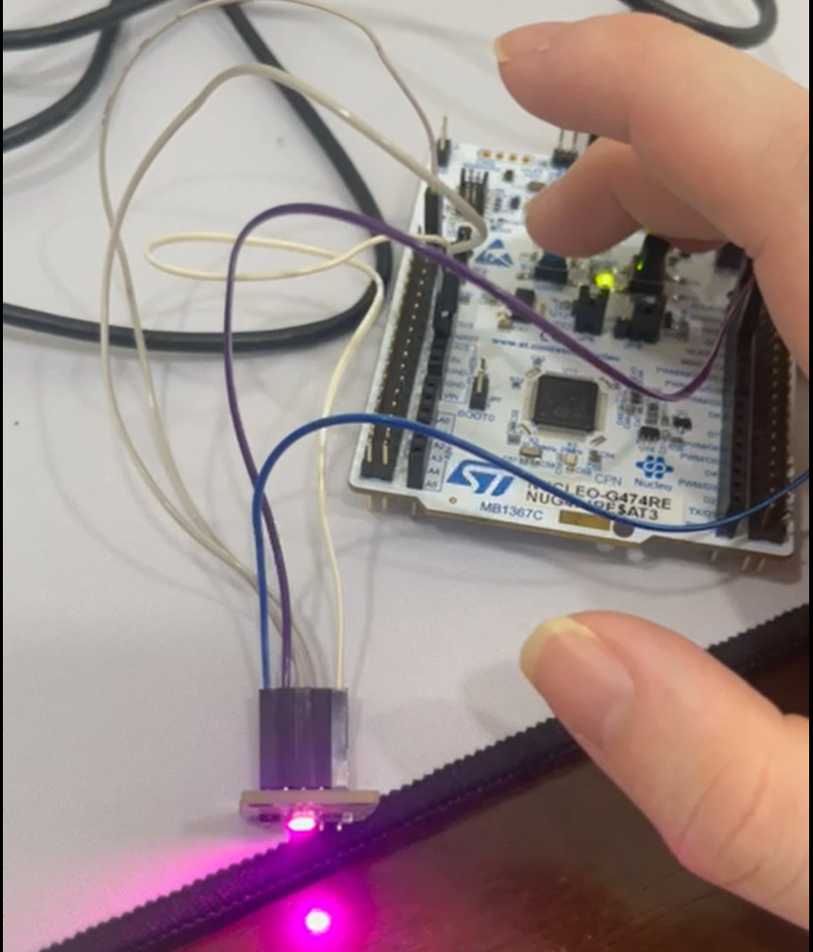

***Figure 6: Light Module utilised to show the colours of yellow, cyan and magenta***

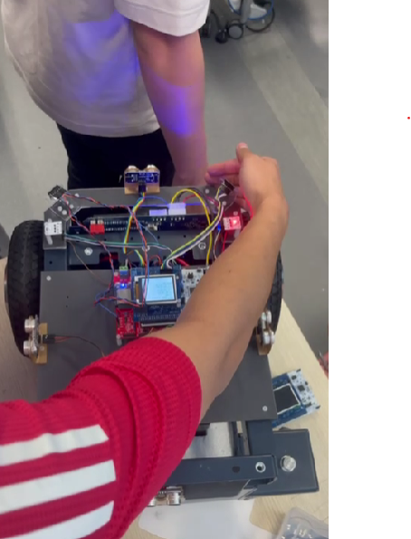

***Figure 7: Light Module integrated into the team’s code and the LED would blink red when turning right***

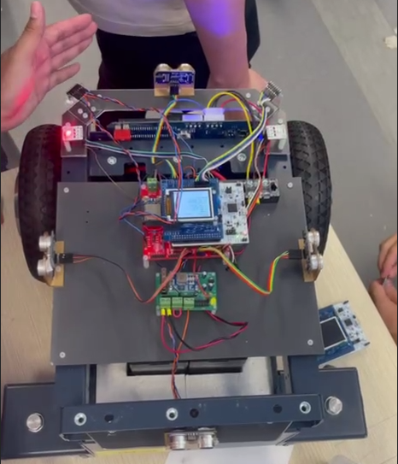

***Figure 8: Light Module integrated into the team’s code and the LED would blink red when turning left***

* Pictorial representation of fail condition:

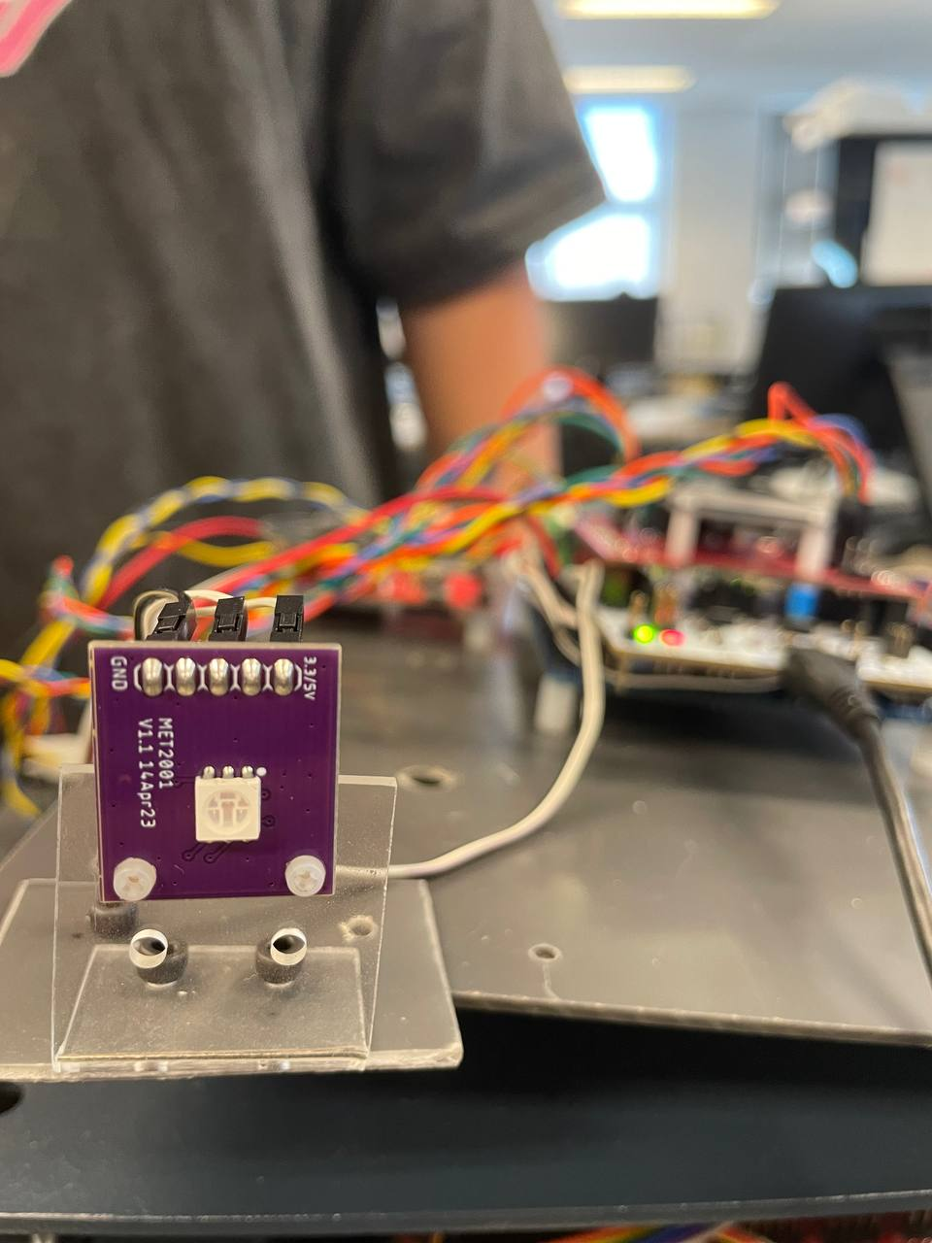

***Figure 9: Light Module integrated into the team’s code and the LED did not blink red when turning left or right***

**4. Emergency Stop**

**Purpose**

* Cut off the current flow from the battery to the rest of the components connected to the tank.

**Initial State**

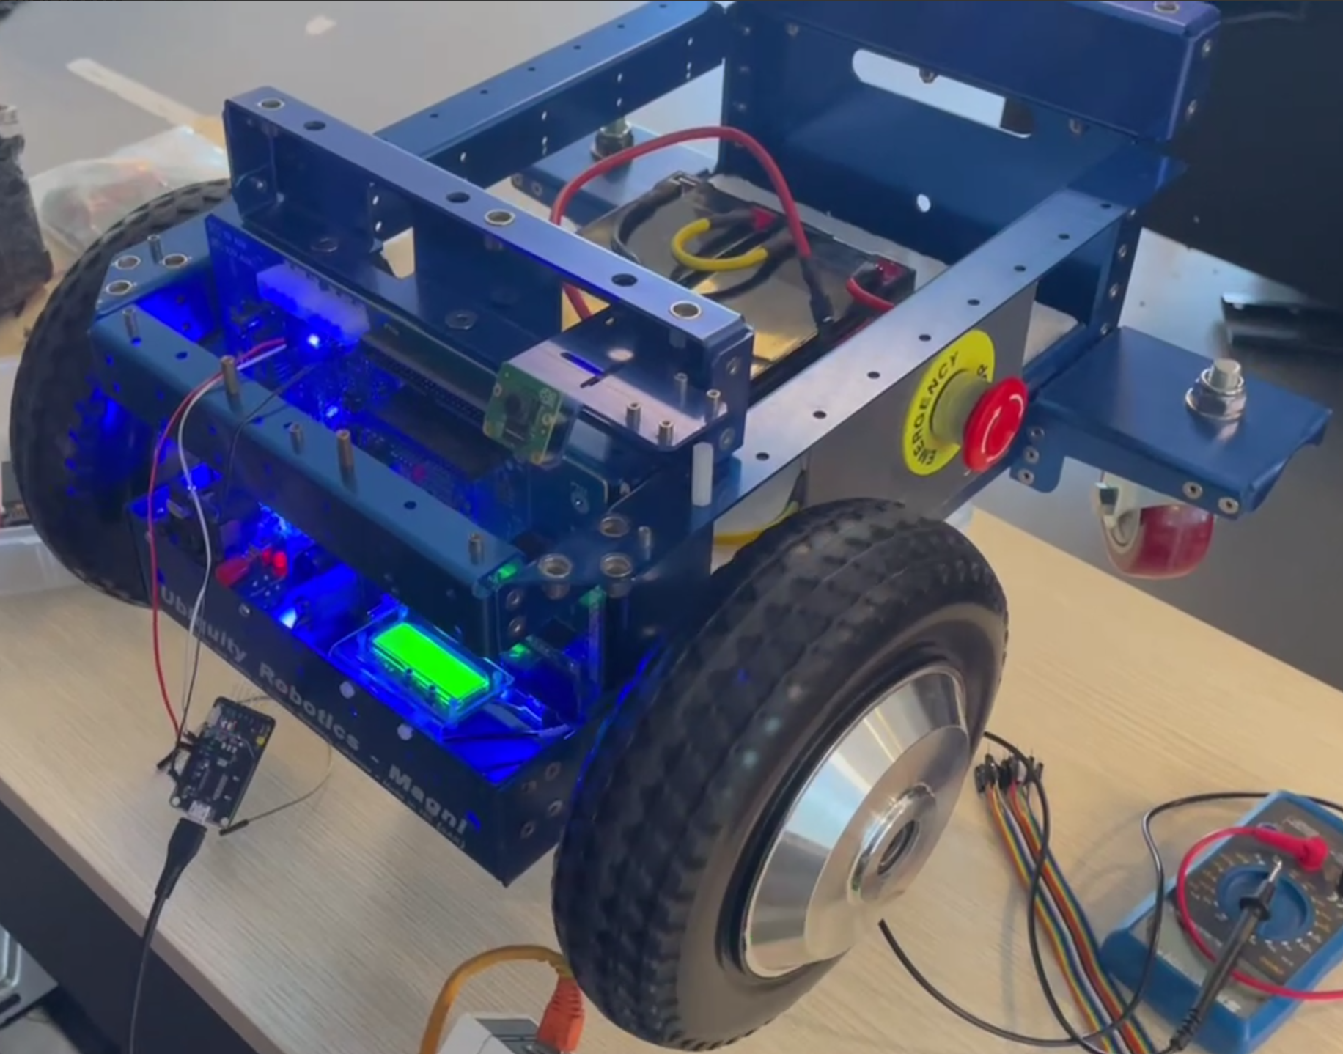

***Figure 10: Power supplied to the AMR when emergency stop is released***

**Testing Plan**

* Ensure tank components are properly connected.
* Ensure tank power and motor power is switched on.
* Ensure no components are hot when physically touched.
* Load movement code in the tank's Nucleo board.
* Ensure code works and wheels are turning.
* Press the E-Stop button firmly.
* Ensure wheels stop moving.
* Ensure motor power and tank power is off.

**Pass/Fail Criteria**

* Pass Criteria:
  + Power is cut off from the AMR when emergency stop is pressed.
* Fail Criteria:
  + Power is still supplied to the AMR when emergency stop is pressed.

**Testing State**

* Pictorial representation of pass condition:

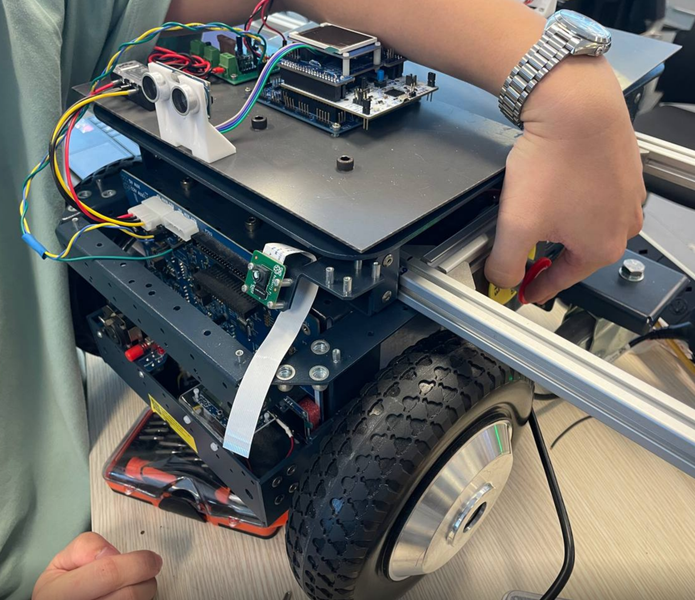

***Figure 11: Emergency stop is pressed and power is cut off from the AMR***

* Pictorial representation of fail condition:

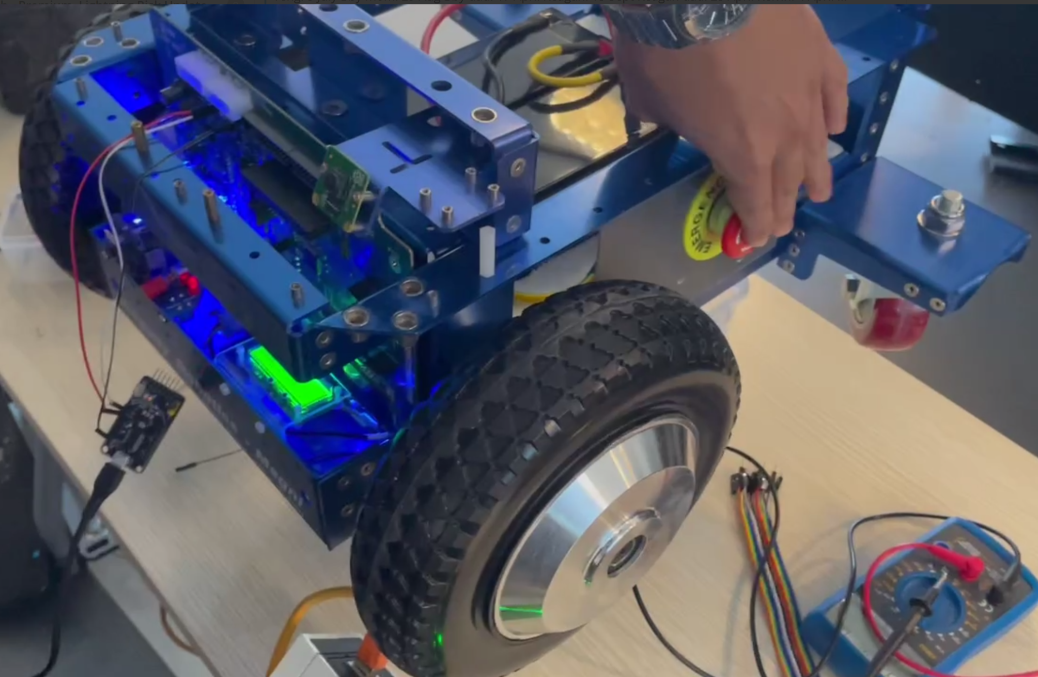

***Figure 12: Emergency stop is pressed but power is not cut off from the AMR***

**5. Ultrasound Sensor & Characterization**

**Purpose**

* The Ultrasound Sensor is used to emit and receive ultrasound waves to determine the distance of an object away from the sensor. In the case of our project, we aim to use the Ultrasound Sensor to determine if there is an obstruction to our AMR and to avoid the obstruction.

**Initial State**

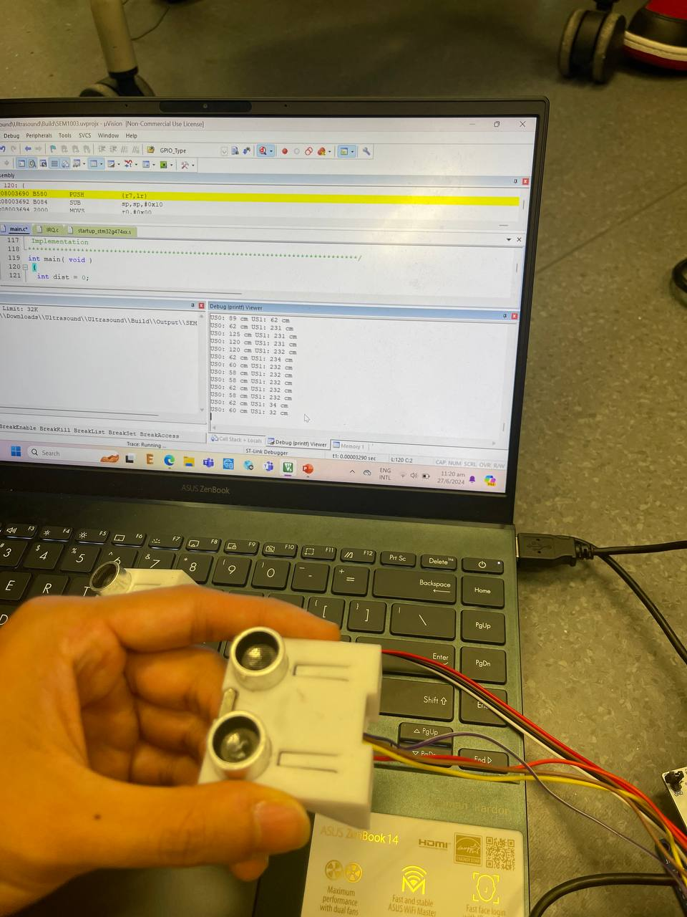

***Figure 13: Ultrasound sensor at initial state when no obstacle is detected***

**Testing Plan**

* Load the ultrasound testing code into one ultrasound sensor
* Place the ultrasound sensor on the ground
* Place a measuring tape beside the ultrasound sensor as a way to verify the distance of the object away from the sensor
* Place an object at the various positions on the measuring tape
* Take various readings of the distance measured by the ultrasound sensor
* Take the average of all the readings to determine accuracy of the sensor
* Repeat the steps above for the second ultrasound sensor

**Pass/Fail Criteria**

* Pass Criteria:
  + Ultrasound distance readings are close to the actual distance of the object away from the sensor
* Fail Criteria:
  + Ultrasound distance readings stray far away from the actual distance of the object away from the sensor

**Testing State**

**US0 sensor readings**

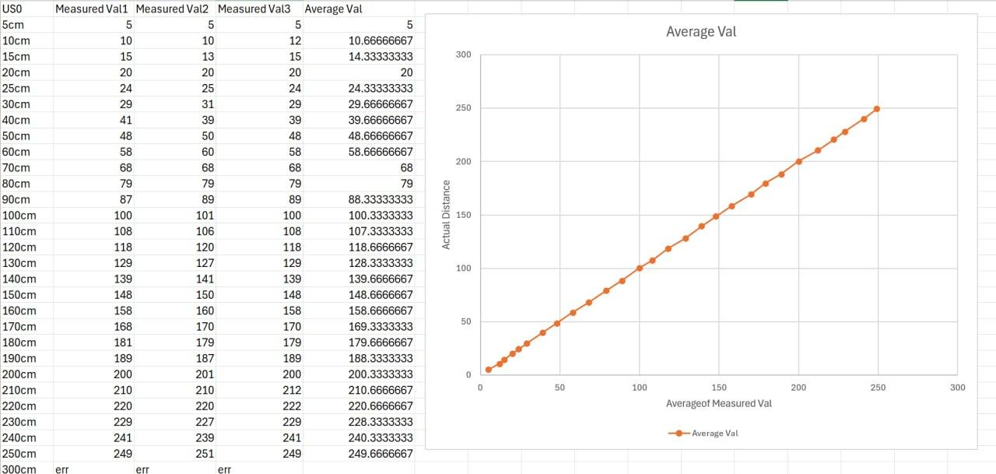

***Figure 14: Readings and graph from ultrasound sensor testing of US0***

**US1 sensor readings**

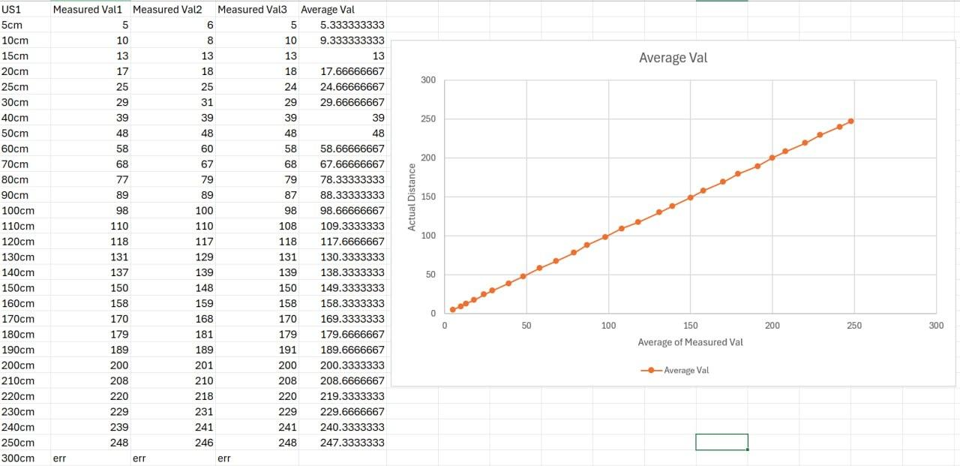

***Figure 15: Readings and graph from ultrasound sensor testing of US1***

3 values were taken for each ultrasound sensor as calculating the average would give us an accurate reading when utilising the sensors to detect distance of an object away from the sensor.

**6. VL53L0X ToF Sensor & Characterization**

**Purpose**

* The VL53L0X Time-of-Flight (ToF) sensor is a compact, high-precision sensor used for distance measurement and proximity sensing. It works by emitting an infrared laser pulse and measuring the time it takes for the pulse to reflect back from a target, thereby calculating the distance based on the speed of light.

**Initial State**

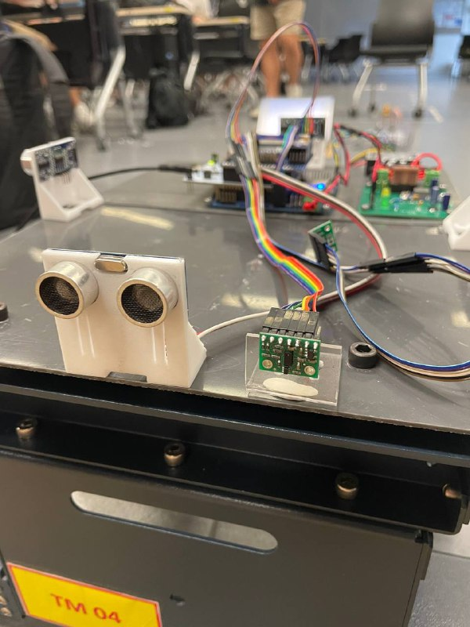

***Figure 16: ToF sensor at initial state when proximity sensing is not activated***

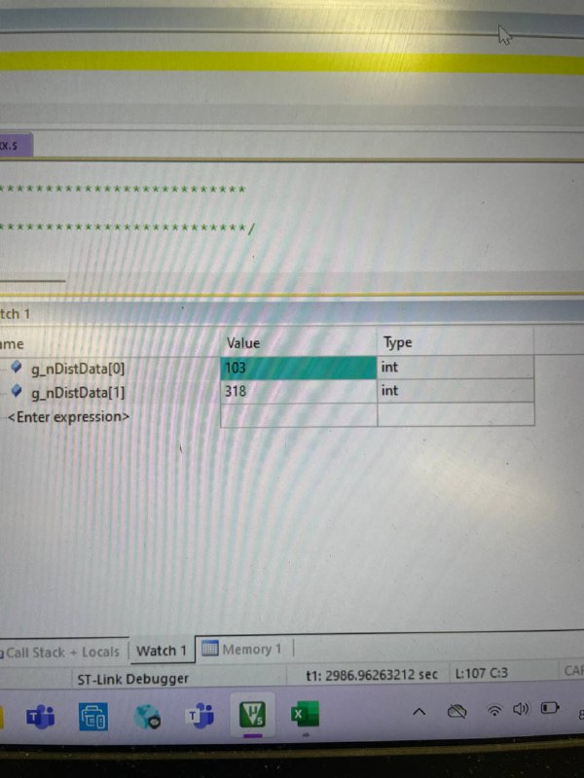

***Figure 17: Values of both ToF sensors were randomly jumping***

**Testing Plan**

* Ensure wiring of the ToF sensor to the mezzanine board is correct.
* Ensure tank components are properly connected.
* Ensure tank power and motor power is switched on.
* Ensure no components are hot when touched
* Load ToF sensor codes into the tank's Nucleo board.

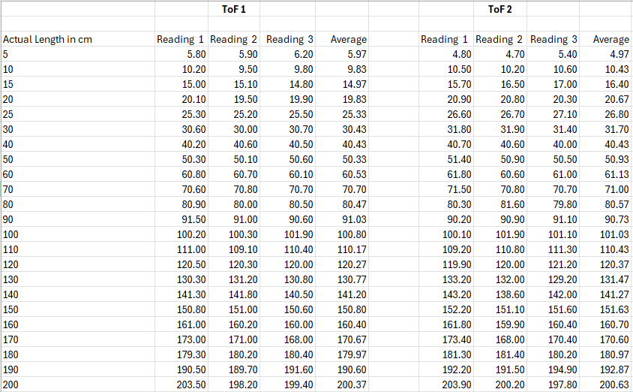

***Figure 18: Values taken from the time of flight sensors***

3 values were taken for each ToF sensor as calculating the average would give us an accurate reading when utilising the sensors to detect proximity.

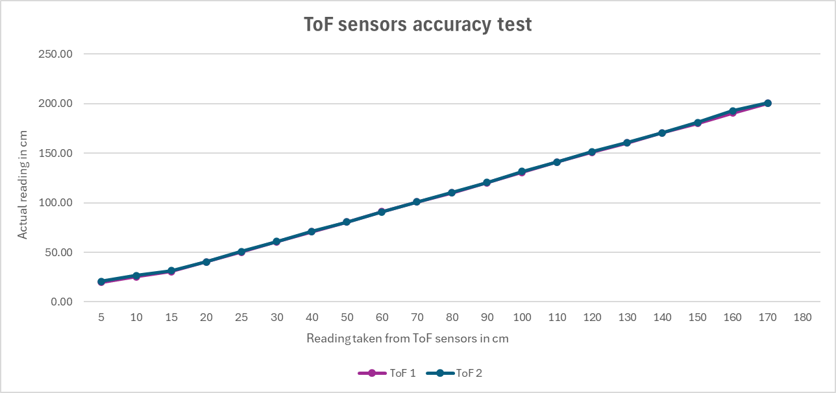

***Figure 19: Representation of values taken from both ToF sensors on a line graph***

**Pass/Fail Criteria**

* Pass Criteria:
  + Accurate readings of the ToF sensors can be viewed from the debug printf window.
* Fail Criteria:
  + False readings were seen on the debug printf window.
  + No values can be seen on the debug printf window.
  + Overheating due to improper wiring.

**Testing State**

* Pictorial representation of pass condition:

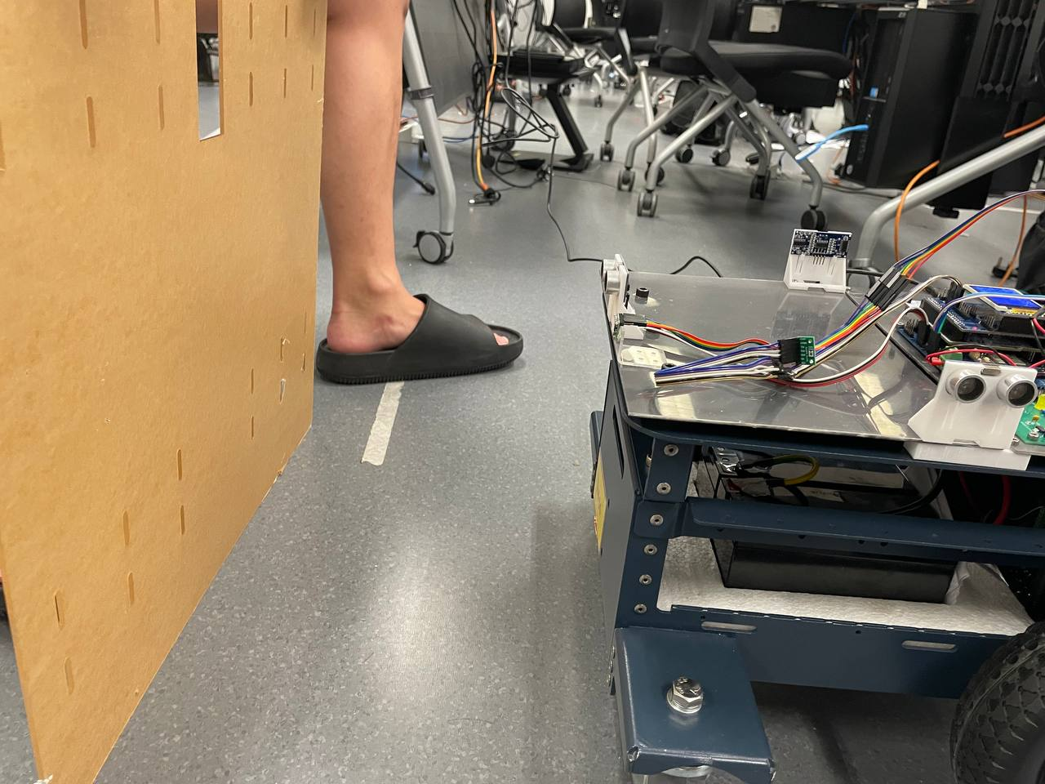

***Figure 20: Cardboard placed at the 30cm mark***

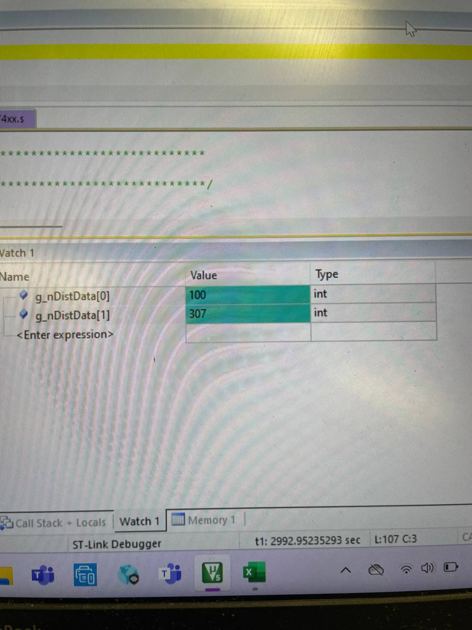

***Figure 21: Reading obtain from the ToF sensor 1 when cardboard board is placed 30 cm away***

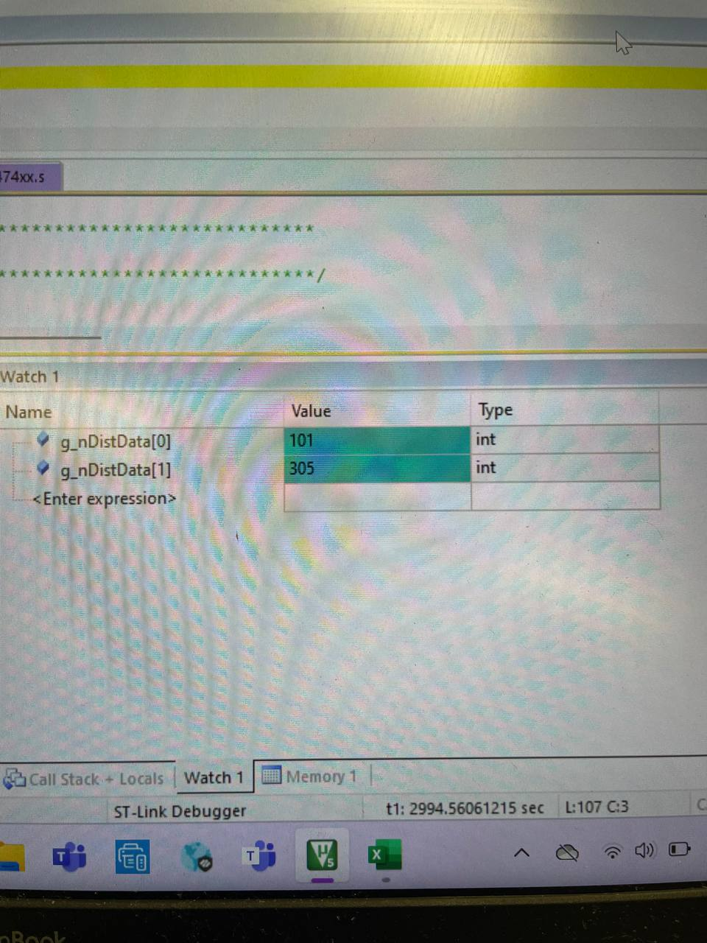

***Figure 22: Reading obtain from the ToF sensor 2 when cardboard board is placed 30 cm away***

*Both readings were taken using the same pinout therefore both readings are seen under g_nDistData[1]. Sensors were swapped when the team tested for accuracy on both ToF sensors.*

* Pictorial representation of fail condition:

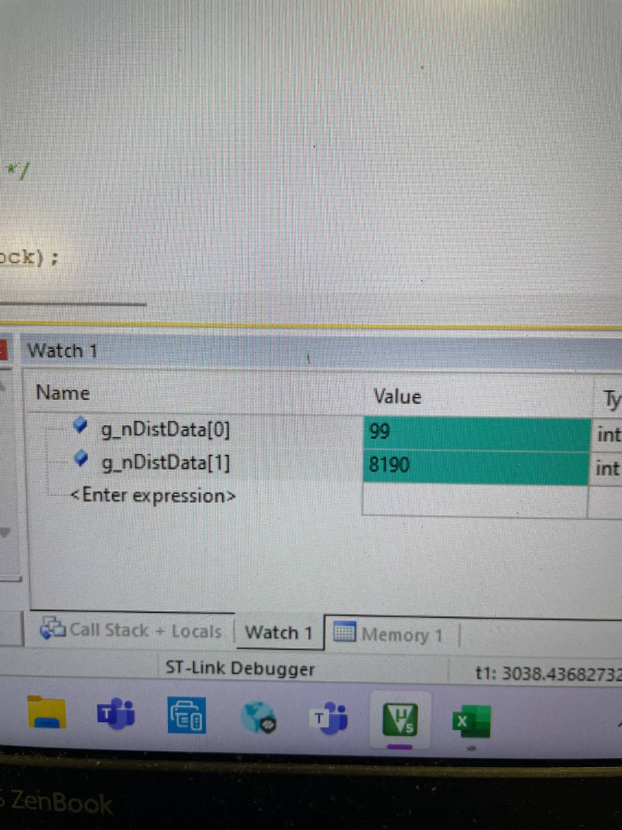

***Figure 23: Inaccurate reading obtained from the ToF sensor when cardboard board is placed 30 cm away***

**7. Vehicle Base - Commands and Movement**

**Purpose**

* The vehicle base is used to control the movement system of our robot tank autonomously and remotely.

**Initial State**

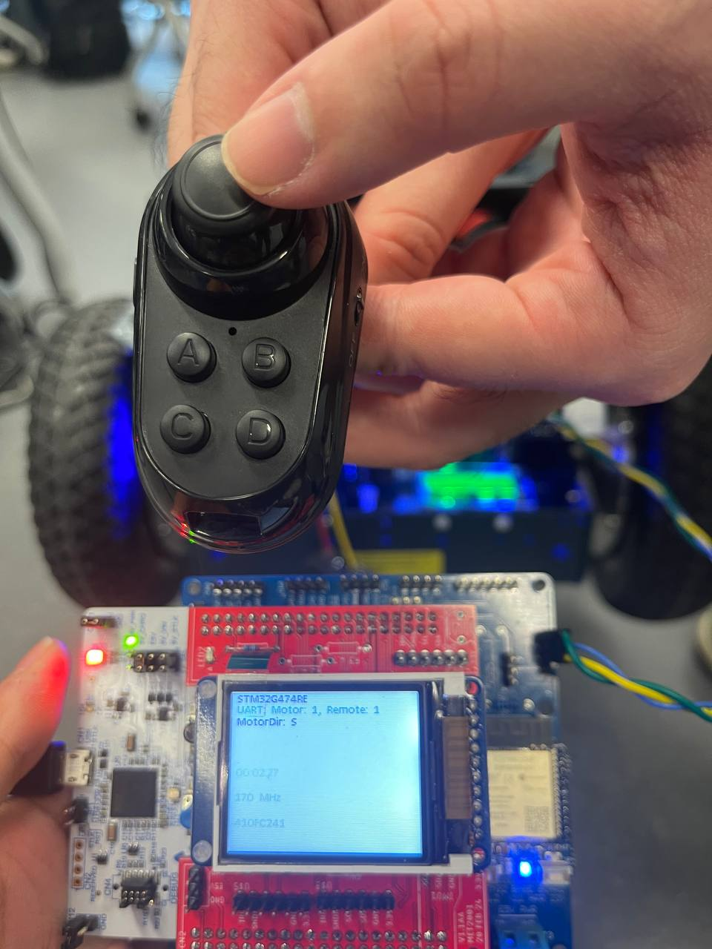

***Figure 24: AMR is stationary when powered on and no inputs are pressed on the R1 Remote Control***

**Testing Plan**

* Ensure that all connections between the components in the AMR are properly secure and connected.
* Power on AMR and motor.
* Ensure AMR has a good battery percentage.
* Load the integrated movement code for both the autonomous movement and the remote controlled movement into the AMR.
* Physically touch the components to ensure that none is hot.

**R1 Remote Control**

* Ensure that the AMR and the motor are receiving inputs from the movement command of the control unit.
* Ensure code is working without errors and the wheels are turning based on the inputs pressed on the R1 Remote Control.
* Ensure that for the remote controlled movement, each direction input on the R1 Remote Control is correctly translated to the AMR movement (i.e. Pushing the joystick forward will make the tank go forward, pushing the joystick backwards will make the tank reverse, pushing the joystick to the right will make the tank go to the right, pushing the joystick to the left will make the tank go to the left.)
* Ensure that the AMR’s movement is consistently accurate.

**Autonomous Movement**

* Ensure that for autonomous movement, the AMR is able to detect an obstacle in the vehicle’s path and perform a change of direction to avoid the obstacle by reversing.
* Ensure that the AMR is also able to perform the change of direction when it detects an obstacle in the vehicle’s path while reversing direction too.
* Ensure that the AMR is able to perform the obstacle avoidance continuously for an extended period of time.

**Pass/Fail Criteria**

* Pass Criteria:
  + AMR is able to respond to all movement inputs from the R1 Remote Control correctly and accurately.
  + AMR is able to successfully execute obstacle avoidance autonomously.

* Fail Criteria:
  + AMR is unable to respond to any movement inputs from the R1 Remote Control correctly (e.g. Joystick is pushing forward, but AMR is not going forward).
  + AMR is unable to perform obstacle avoidance and collides with the obstacle in the vehicle’s path.

**Testing State**

* AMR R1 Remote Control Verifications.
* LCD screen displays the motor direction of the remote control input:
  + “MotorDir : B” indicates that the motor is going backwards
  + “MotorDir : F” indicates that the motor is going forward
  + “MotorDir : L” indicates that the motor is going left
  + “MotorDir : R” indicates that the motor is going right
  + “MotorDir : S” indicates that the motor is stop

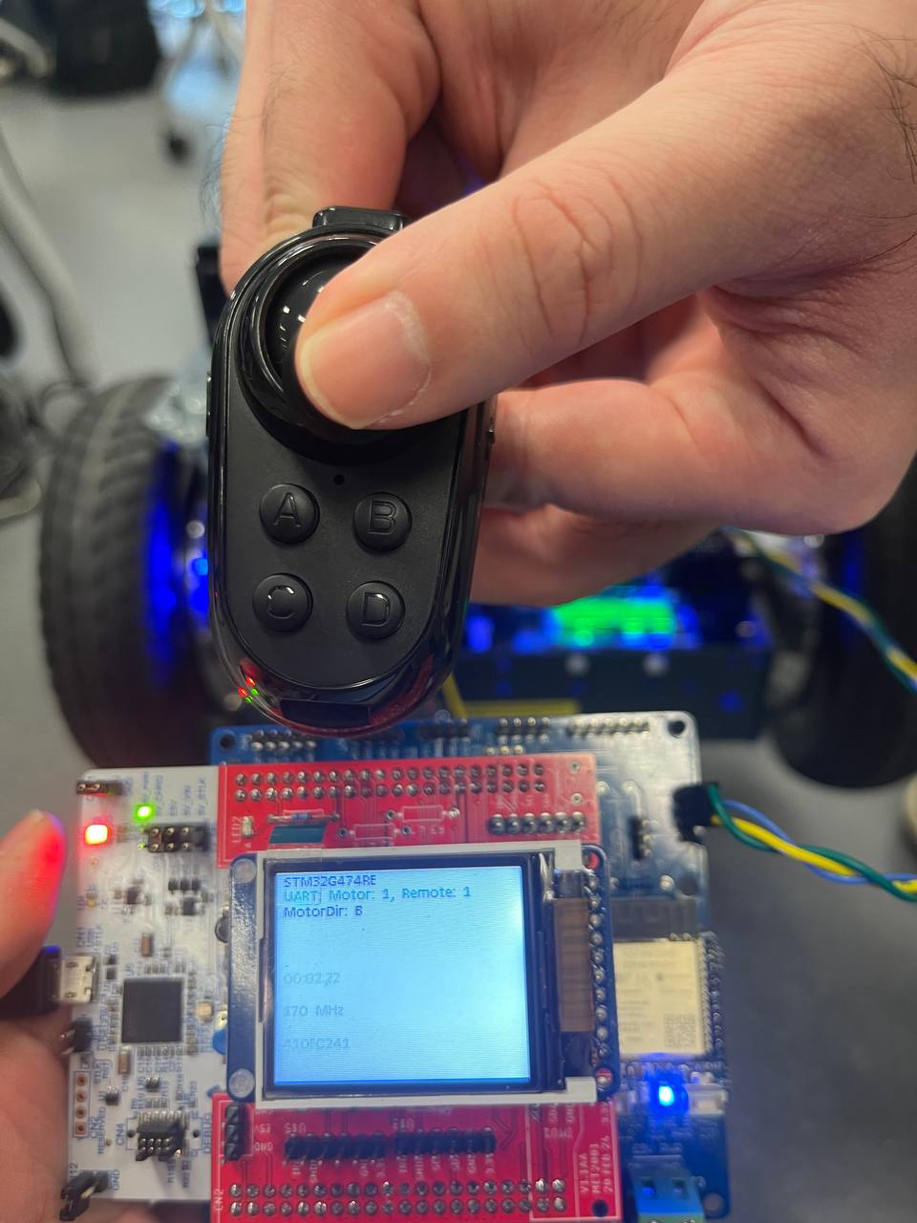

***Figure 25: R1 Remote Control Joystick position at downwards (Backward)***

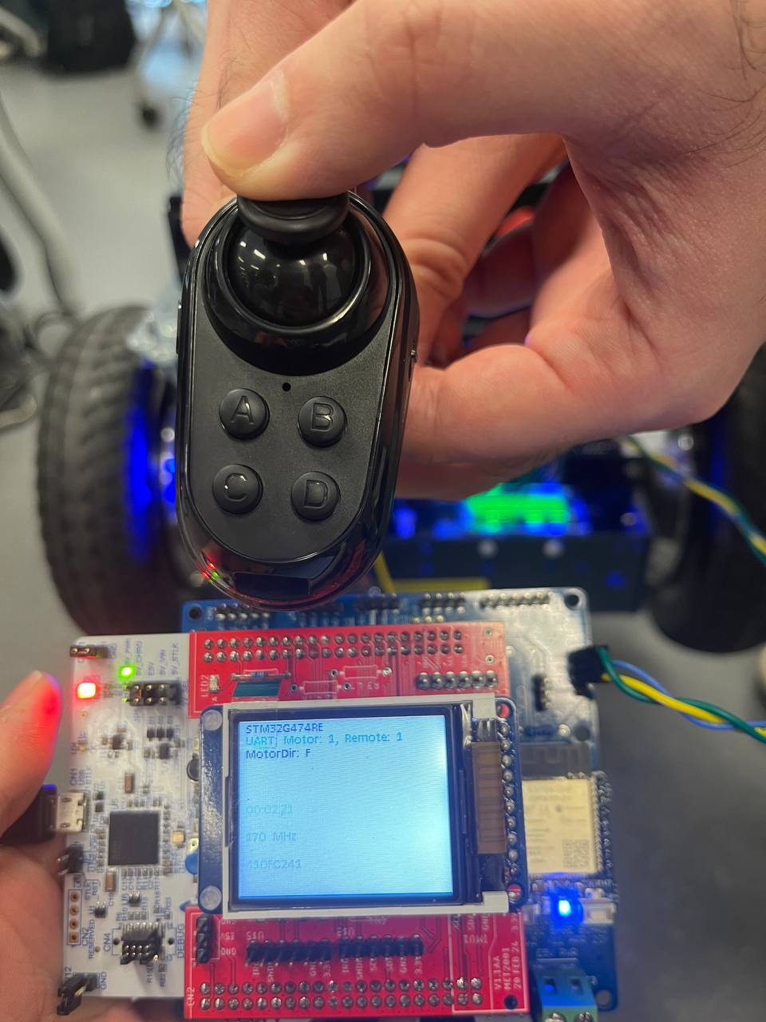

***Figure 26: R1 Remote Control Joystick position at upwards (Forward)***

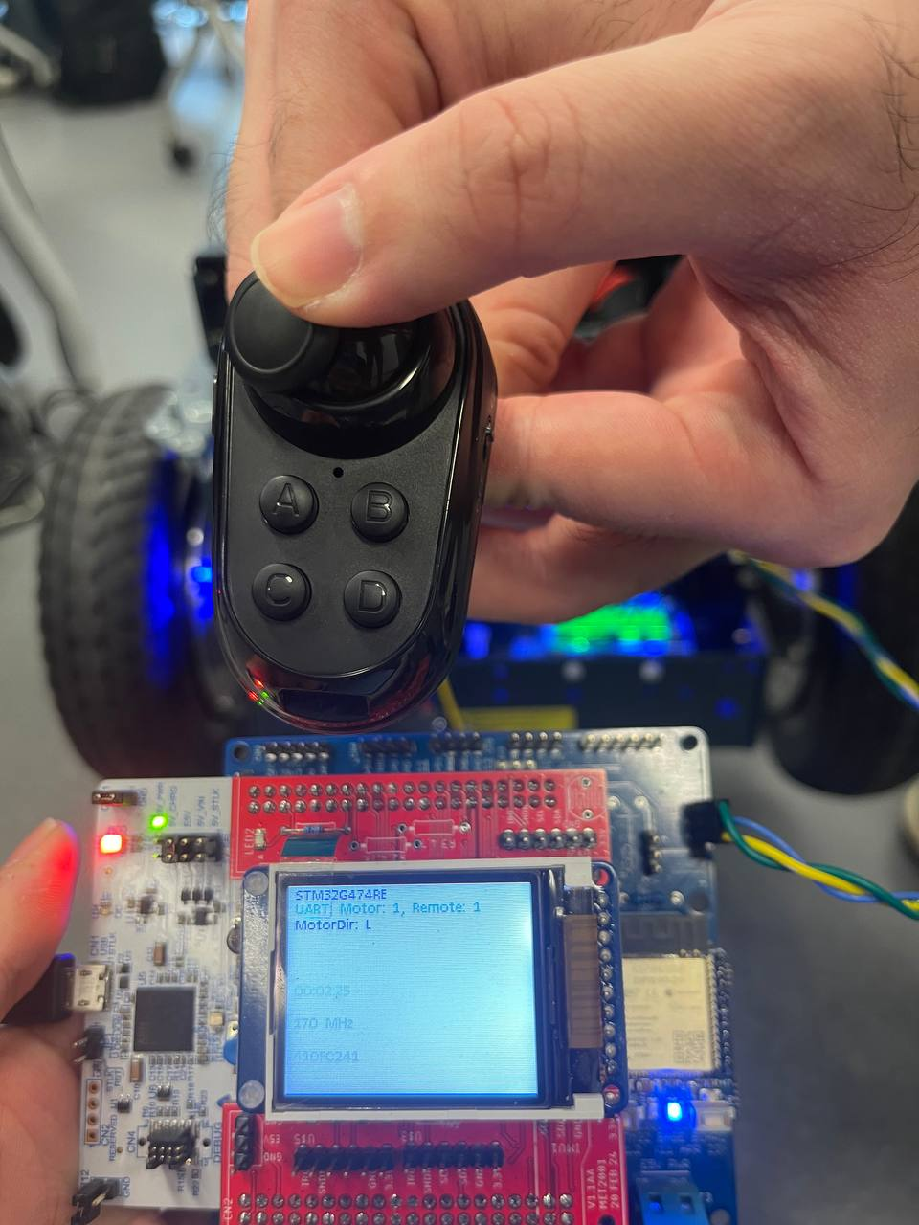

***Figure 27: R1 Remote Control Joystick position at leftward (Left)***

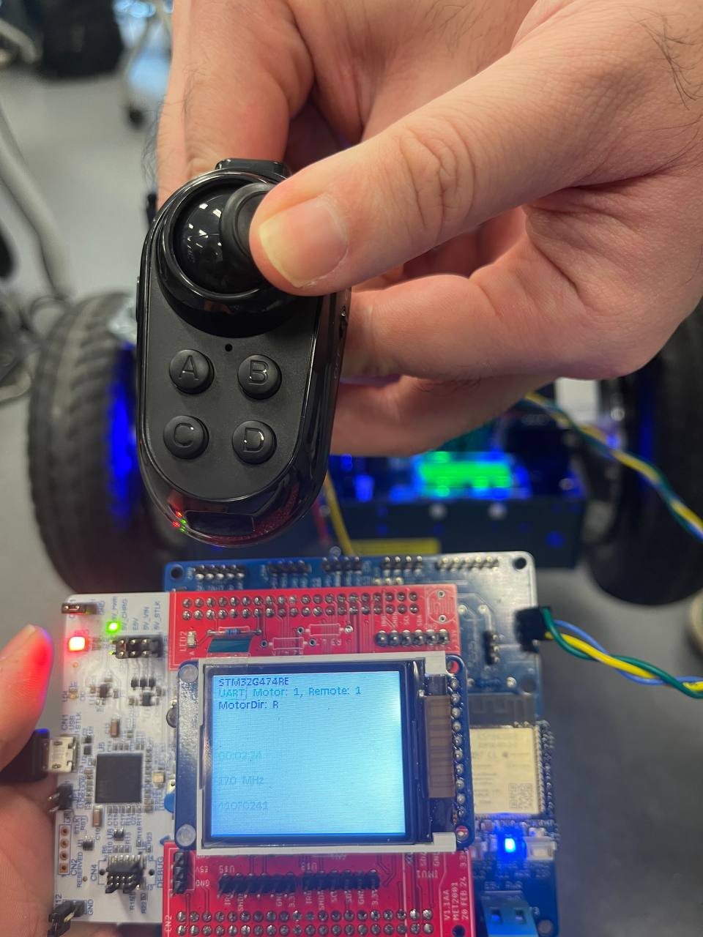

***Figure 28: R1 Remote Control Joystick position at rightward (Right)***

* Pictorial representation of pass condition:

***Table 1: AMR States during autonomous movement***

| State | Verification | Description |
| --- | --- | --- |
| 1 |  | AMR is stationary initially and proceeds to move forward in direction until an obstacle is detected in the vehicle’s path. |
| 2 |  | AMR detects an obstacle and proceeds to stop and change direction.. |
| 3 |  | AMR goes backwards to avoid the obstacle successfully. |
| 4 |  | AMR proceeds to move backwards until another obstacle is detected again in the vehicle’s path. |
| 5 |  | AMR detects an obstacle and proceeds to stop and change direction. |
| 6 |  | AMR goes forward again to avoid the obstacle successfully. |

**8. Navigation Algorithm Verification**

**Purpose**

* The navigation algorithm is to ensure that the AMR is able to complete the course by avoiding the obstacles and restricted area autonomously.

**Initial State**

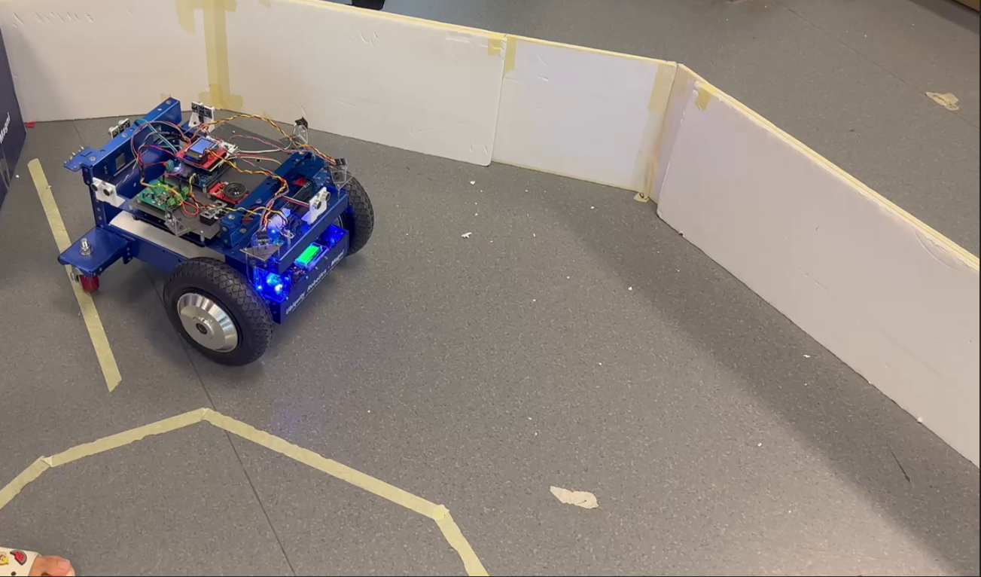

**Figure 29: AMR in starting position of course**

**Testing Plan**

* Ensure correct and proper wiring of components.
* Power on AMR and motor.
* Ensure AMR has a good battery percentage.
* Physically touch the components and ensure that no components are hot when touched.
* Load navigation code into AMR Nucleo board.
* Ensure that Ultrasound and ToF sensors are working and reading values as displayed on LCD display.
* Press the blue button to start.
* Observe and ensure that the AMR does not hit the walls and cross into the restricted area when completing the course.
* Ensure the AMR stops when there are obstacles in front as the front sensor reads a certain value.

**Pass/Fail Criteria**

* Pass Criteria:
  + AMR is powered properly and has a good battery percentage.
  + No components are hot.
  + Code loads into AMR successfully and works as intended.
  + Ultrasound and ToF sensors are working properly.
  + AMR completes the course without hitting obstacles and crossing restricted area.
  + AMR stops when the front sensor reads a certain value as there are obstacles in front.
* Fail Criteria:
  + AMR does not power on correctly.
  + Components feel hot when touched (indicating that components are not wired correctly or the components have been shorted etc.)
  + Code does not load into AMR or code does not work as intended.
  + AMR does not move
  + AMR hits obstacles while completing the course.
  + AMR strays off course and does not complete the course.

**Testing State**

* Pictorial representation of pass condition:

***Table 2: Successful AMR States for navigation algorithm***

| State | Verification | Description |
| --- | --- | --- |
| 1 |  | AMR is stationary initially and proceeds to move based on the code once the blue button is pressed. |
| 2 |  | ToF reads a certain value and the AMR turns right to avoid the obstacle and proceeds to move forward once cleared from the obstacle. |
| 3 |  | ToF reads a value that is too far away from the wall and AMR turns left to avoid the crossing into the restricted area, before moving straight again. |
| 4 |  | ToF reads a value that it is too close to the wall and AMR proceeds to move right till it is cleared from the wall and continues moving straight again. |
| 5 |  | ToF once again reads a value that it is too close to the wall and AMR proceeds to move right till it is cleared from the wall and continues moving straight again. |
| 6 |  | AMR reaches the final path for the course and turns right to straighten itself after ToF detects the wall on the left. |
| 7 |  | Front sensor detects an obstacle 30 cm in front and AMR would stop |

* Pictorial representation of fail condition:

***Table 3: Various Unsuccessful AMR States for navigation algorithm***

| State | Verification | Description |
| --- | --- | --- |
| 1 |  | AMR is stationary initially and once the blue button is pressed, it still remains stationary. |
| 2 |  | ToF reads a certain value and the AMR turns right to avoid the obstacle. However, the AMR hits the wall while turning |
| 3 |  | AMR did not stop even when there was an obstacle in front. |